**Demonstarting Gaussian Timer and Poisson Timer :**

Gaussion Delay can after deviation milliseconds that is sec 2 minimum to maximum constant delay 4 secs.

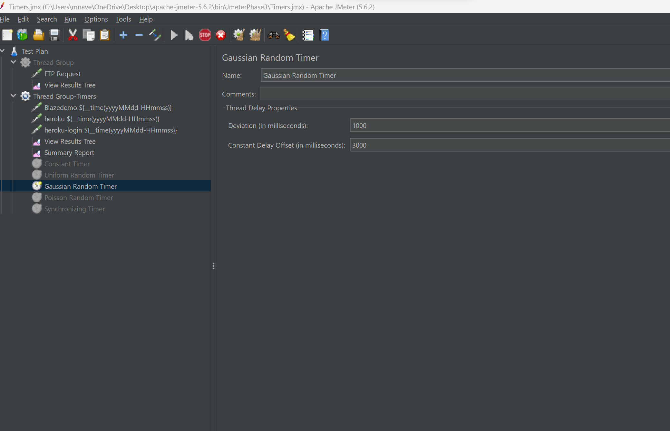

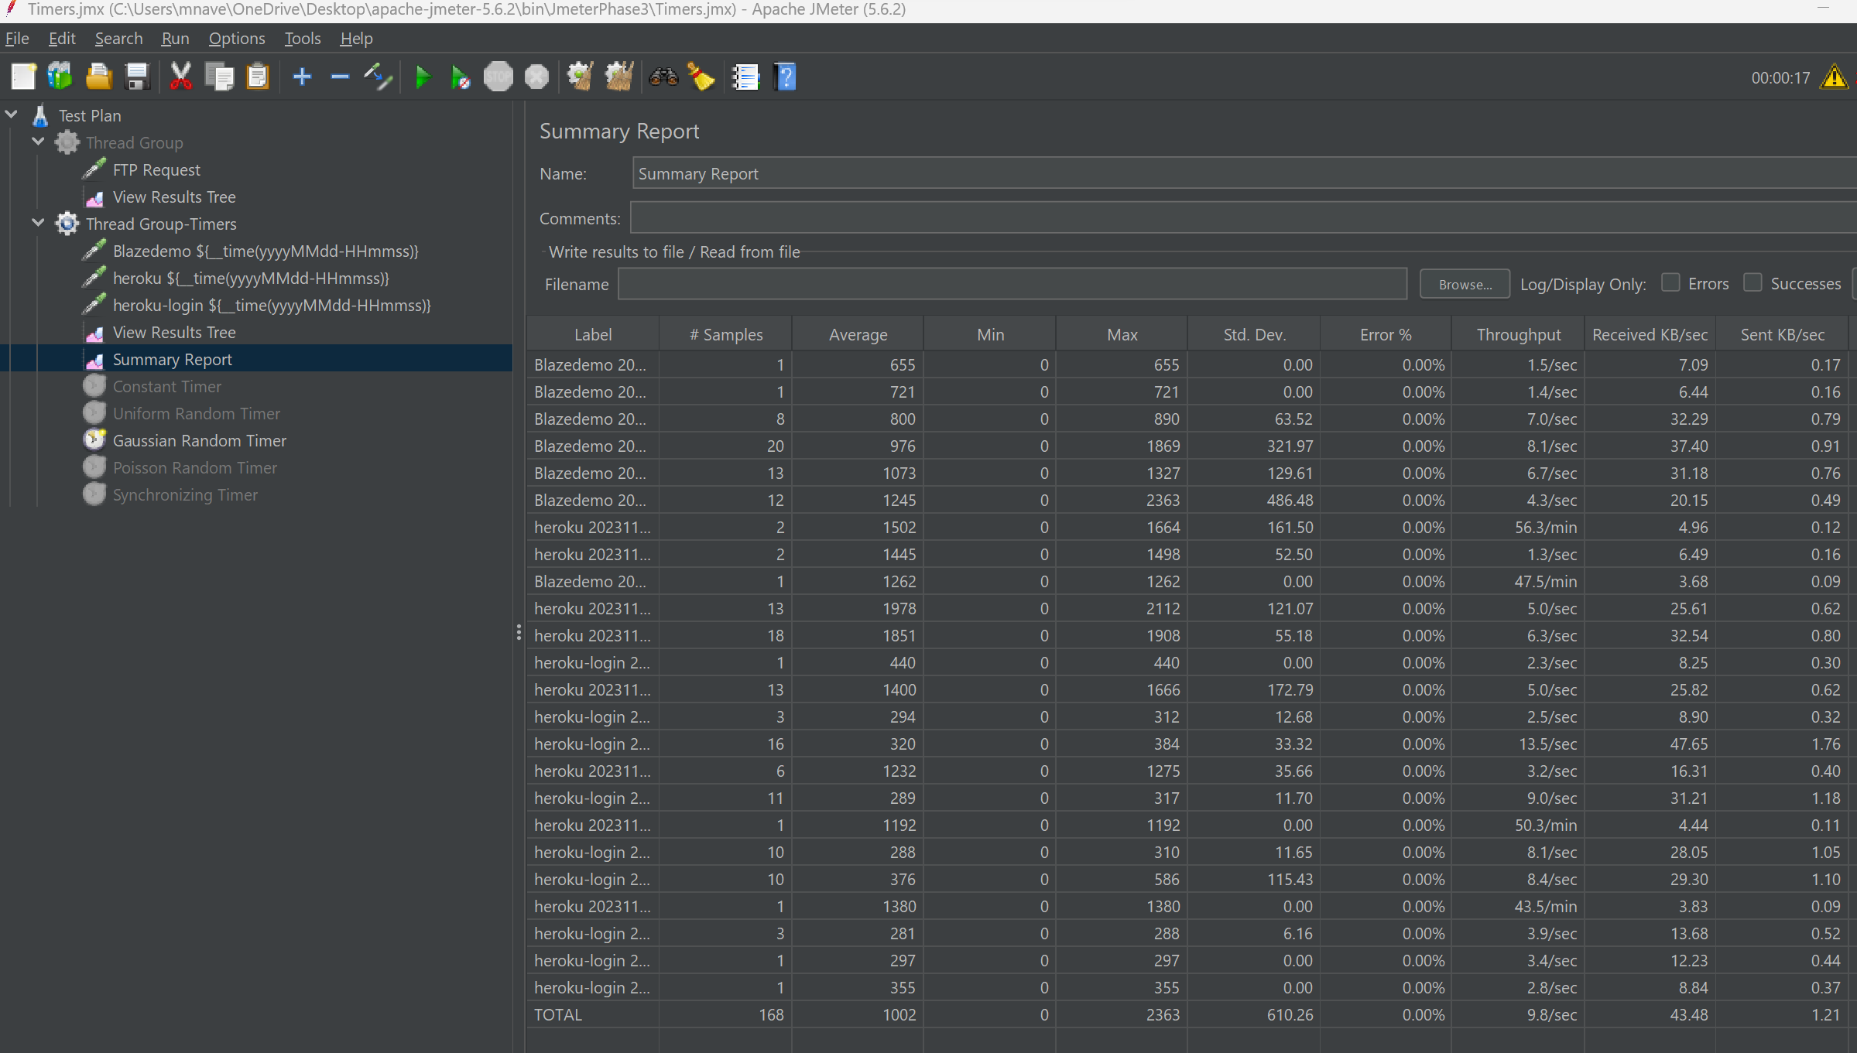

Poisson Random timer:

Timer passes each thread requests for a random time.

